**COURSE: Drone Technology Fundamentals (Id10)  *Teacher: Mrs. N. Penn WGHS***

**Email: pennn@gcsnc.com *Phone: School (336) 316-5800 / Google Voice (336) 265-6496***

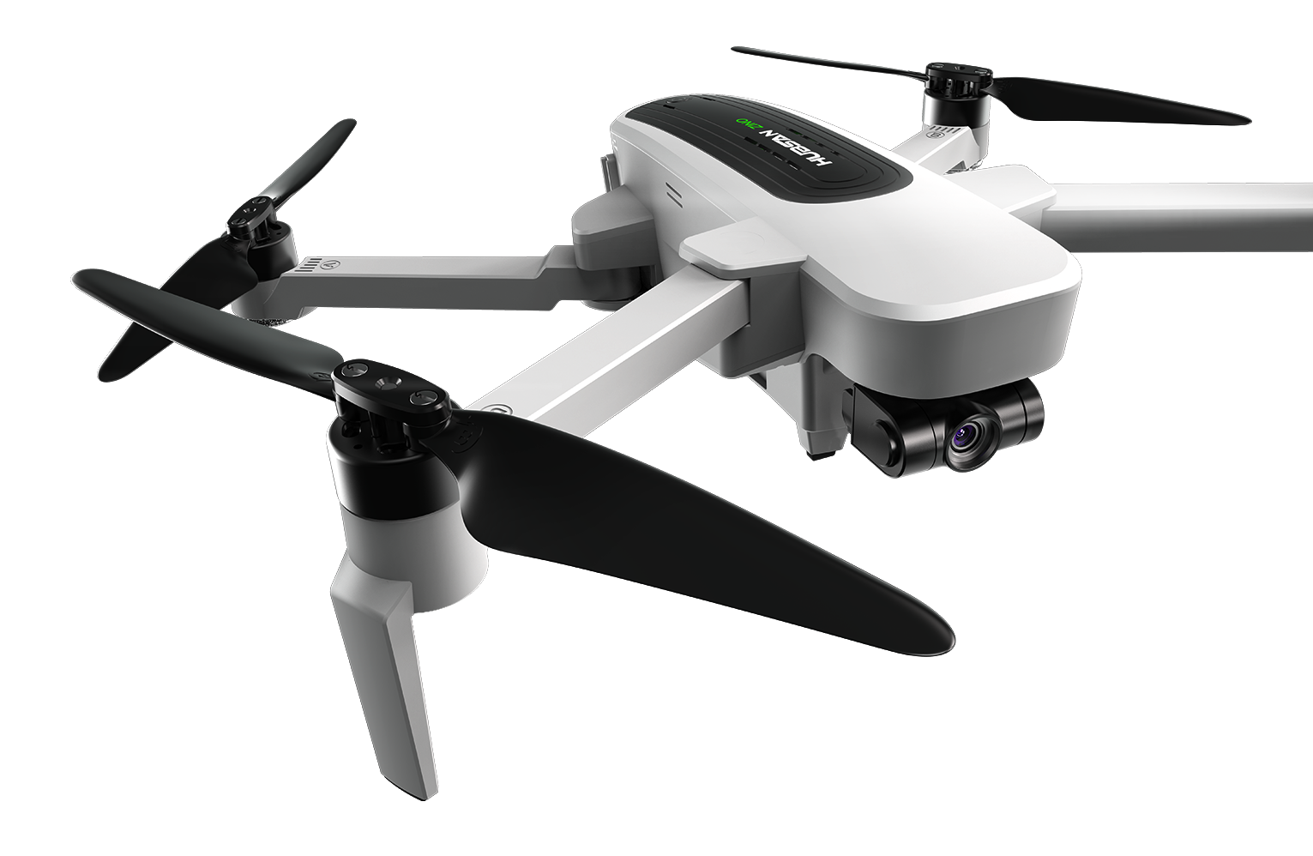

**Course Info:** Welcome to **Drone Technology Fundamentals.** This is a Honor’s level course that will provide you an understanding for how to fly a drone autonomously using computer programming. And, give you a foundational understanding needed to be a Part 107/FAA Certified Drone Pilot in your Junior year which will improve your performance next year on test & class.

**Grading Scale**:

Process 60%

(ex: HW/Classwork/Skill Demo)

Product 40%

(ex: Projects, Assessments)

Late Policy: After 1st week, pts will be deducted in increments daily/weekly

**Tuesday Tutoring- 4:30 to 5:30 by appt.

*Assessments are usually administered on Thursdays but subject to change. Quizzes maybe unannounced.

**Course Objectives**:

To equip students to attain the skills & knowledge needed to safely conduct drone flights abiding by FAA regulations. And, to prepare for being successful in next year’s drone course to attain FAA license.

**Course Info/ Description:**

1.00: Understand the foundations of aviation.

2.00: Understand unmanned aircraft systems.

3.00: Understand aeronautical charts for small, unmanned aircraft systems.

4.00: Understand unmanned aircraft system autonomous flight.

5.00: Apply procedures for recreational flight of small, unmanned aircraft systems.

FAA 14 CFR Part 107 Test Content and Breakdown

|  |  |
| --- | --- |
| AREAS of OPERATIONS |  |
| I. Regulations | 15-25% |
| II. Airspace & Requirements | 15-25% |
| III. Weather | 11-16% |
| IV. Loading & Performance | 7-11% |

.

m

**Academic Policies and Procedures:**

Students will be given opportunities for tutoring, support as well as enrichment to boost comprehension.

*NOTE: If failing class at end of quarter* ***students must*** *set up a conference time to review means for developing routine ensure success*

**Expectations\***: To assist in bringing life to our goals the following guidelines for class behaviors are expected that we call “REP CPR” in our BeeHive Drone Rm…DAILY….

*Be* ***R****espectful, Be* ***E****xcellent, Be* ***P****repared,*

*Be* ***C****ompliant, Be* ***P****repared, and Be* ***R****esponsible*

**Course Resource/Materials:**

***Provided***: Cost for FAA Drone Exam, Drones, Safety Equipment & more*

***Materials Needed****:* (see below)

* Notebook -spiral or composition
* *Cell Phone w/ability to download apps

*(w/data plan is a plus)* ,

* Pack of 3”x5” index cards
* Magnifying glass keep at home until FAA testing date
* *TBA/TBD: Possible Fee ($15) for AMA flight membership /insurance

**Assessment of Learning**: Students will be evaluated by PBM, projects/flight missions, assessments, notebook checks

**Final Exam:** PBM: Performance Based Measured Assessment/Project

Students will create an automated flight to simulate a solution to a real-world problem. Research product exploring careers in aviation that aid in solving a real-world problem. A mock scene with a chart will be created to demonstrate the solution by flying the drone autonomously after demonstrating parts inspection& safety cks.

**\*Electronic Communication**

*“Out of sight, Out of sound”* **No** phones/No ear buds/No electronic devices should be out during class without teacher permission.

*KEYS TO SUCCESS: *Examples of Ways to Ensure Expectations are Met are to*….

*Exhibit an Exemplary Attitude/Work Ethic Daily, Be Willing to Work As a Team, *Being On Time, *Be physically, mentally & emotionally Present, *Complete all Assignments & Make up Work if Absent, *Take Turns Talking, *Be Non-Confrontational, *Accept Constructive Criticism, *Stay Engaged, *Ask Questions as needed, *Practice Safety at All Times, *Ensure no electronics are used without permission – no Earbuds, No Cellphones out or in use unless with approval, *Refrain from using Profanity & **Use only Kind Words**…

**Rewards:** Extended Flight Time, Student of the Month Recognition, Drawings for Incentives, Selection/Recommendations for Special Field Trips

**Consequences:** Warning, Isolation, After-School Detention, Call Home, Referral (Note: order may vary based on incident)

***Next:*** *Sign & Return* Attached Pg. by Sept 10th